Does the Home Run Derby Change How Hitters Hit? A Matched-Comparison Study of Batted-Ball Approach
Jack Rollo

Introduction
The goal of this research project is to evaluate the potential influence of participation in the MLB Home Run Derby on batted-ball results and approach. Statistics measuring a player’s performance such as OPS (on-base percentage + slugging percentage) and batting average (a player’s total number of hits divided by their number of at bats) have a multitude of variables impacting them, including opposing defense and luck, which are beyond the hitter’s control. An examination of batted-ball data provides a discrete glimpse into a potential shift in a hitter’s approach. This study asks whether Derby participants' batted-ball profiles change from the first to the second half of the season relative to matched non-participating All-Stars. Because Derby swings reward pulling the ball in the air, participants may shift toward a more pull-oriented, fly-ball-heavy approach.

Materials and Methods
The data covers 88 Home Run Derby participant-seasons from 2015–2019 and 2021–2026. Statcast pitch-level data (Baseball Savant, n.d.) were used to compute first-half matching variables and classify home-run direction, while FanGraphs batted-ball splits (FanGraphs, n.d.) provided the outcome measures (Pull%, FB%, and HR/FB).
Matching. Players with at least 150 plate appearances in both halves were considered eligible (85 participants). Each participant was paired with a non-participating All-Star from the same season (342 candidates) based on six first-half Statcast variables: Pull%, FB%, HR/FB, K%, average exit velocity, and average launch angle. Similarity was measured by Mahalanobis distance, which combines the standardized variables while accounting for correlations among them (Stuart, 2010). Pairs were accepted only if their distance fell within a pre-set cutoff that only the closest 10% of random hitter pairs would meet, producing 71 matched pairs. Match quality was assessed with standardized mean differences.
Analysis. The primary outcome was the first-to-second-half change in a Pull-Air Index, the average of a player's standardized FanGraphs Pull% and FB%, with both halves standardized against first-half values of all eligible players. Participants and controls were compared with a linear regression adjusting for first-half values to account for regression to the mean (Barnett et al., 2005). Secondary outcomes, the changes in HR/FB and in the share of home runs pulled, used the same model at a Bonferroni-corrected α = .025 (Armstrong, 2014). Home-run direction was classified from Statcast hit coordinates, agreeing with manual coding on 97.8% of home runs.
Early Results
Of the 88 participant-seasons, 85 met the plate-appearance requirement, and 71 were matched to a non-participating All-Star; the remaining 14 had no control within the matching cutoff and were excluded from the matched comparison.
Matching substantially reduced first-half differences between participants and the pool of non-participating All-Stars. Before matching, participants differed most in HR/FB (standardized mean difference = 0.74), K% (0.59), and average exit velocity (0.53), reflecting the power-hitting profile that warrants a Home Run Derby invitation. After matching, these gaps fell to 0.27, 0.20, and 0.18, respectively. Some imbalance remained, most notably in FB% (0.29), which exceeds the commonly used 0.25 threshold for acceptable balance (Stuart, 2010). Because FB% is one of the two components of the Pull-Air Index, the primary analysis adjusts for each player’s first-half values rather than relying on matching alone.
Figure 1
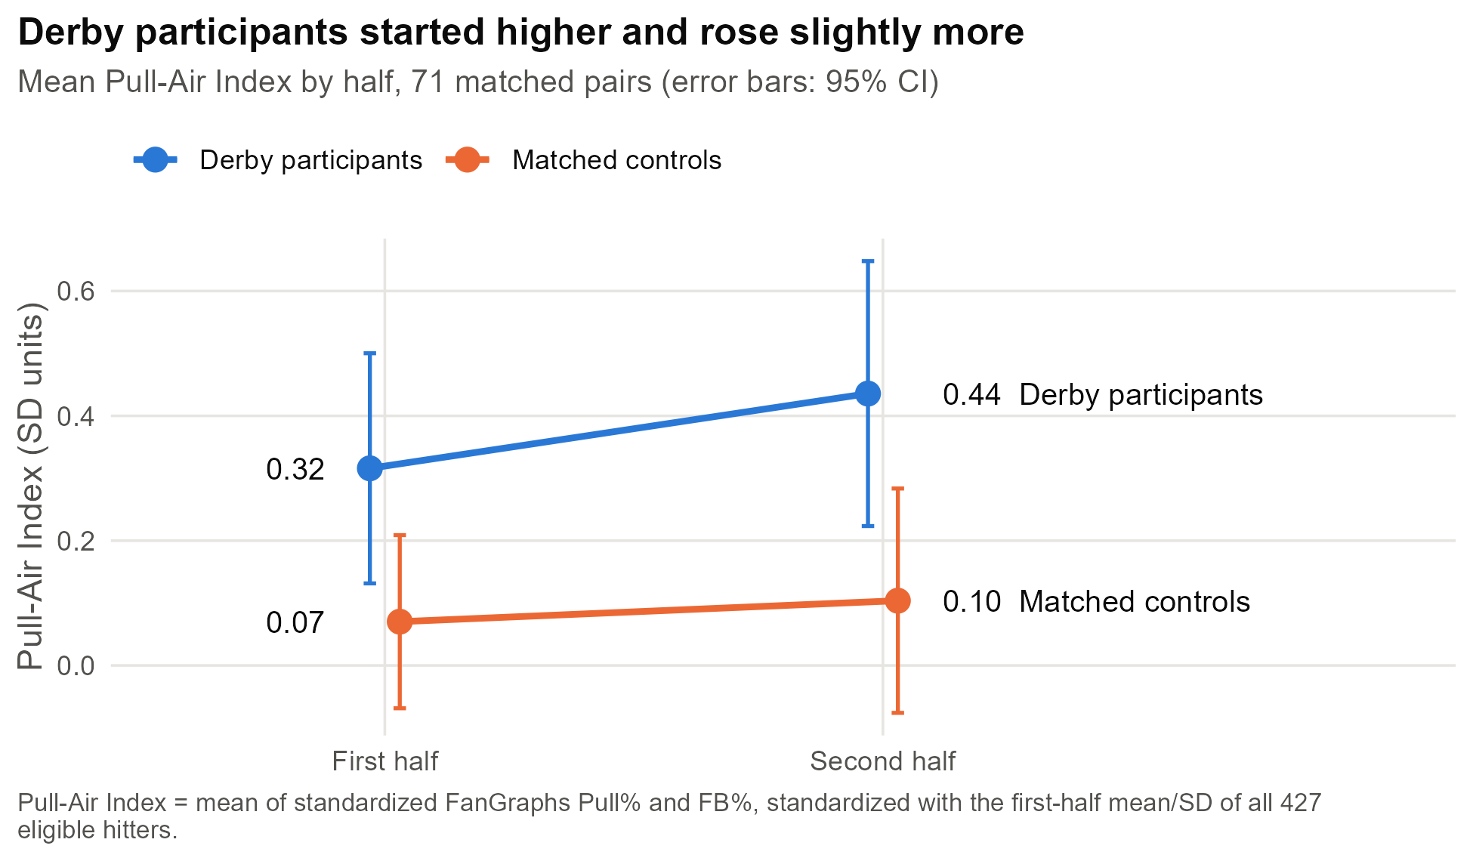
Higher Pull-Air Index values indicate a more pull-oriented, fly-ball-heavy approach, with 0 representing an average hitter. As shown in Figure 1, participants entered the second half with a higher index than their matched controls (0.32 vs. 0.07 SD units) and increased more after the break, rising to 0.44 compared with 0.10 for controls. After adjusting for first-half values, participants’ index increased by 0.11 SD units more than controls’, but this difference was not statistically significant (95% CI [−0.08, 0.29], p = .25). The increase was driven by pulling rather than lifting the ball: participants’ Pull% rose from 42.9% to 44.3% while controls’ was essentially unchanged (41.7% to 41.2%), and FB% changed little in either group.
Figure 2
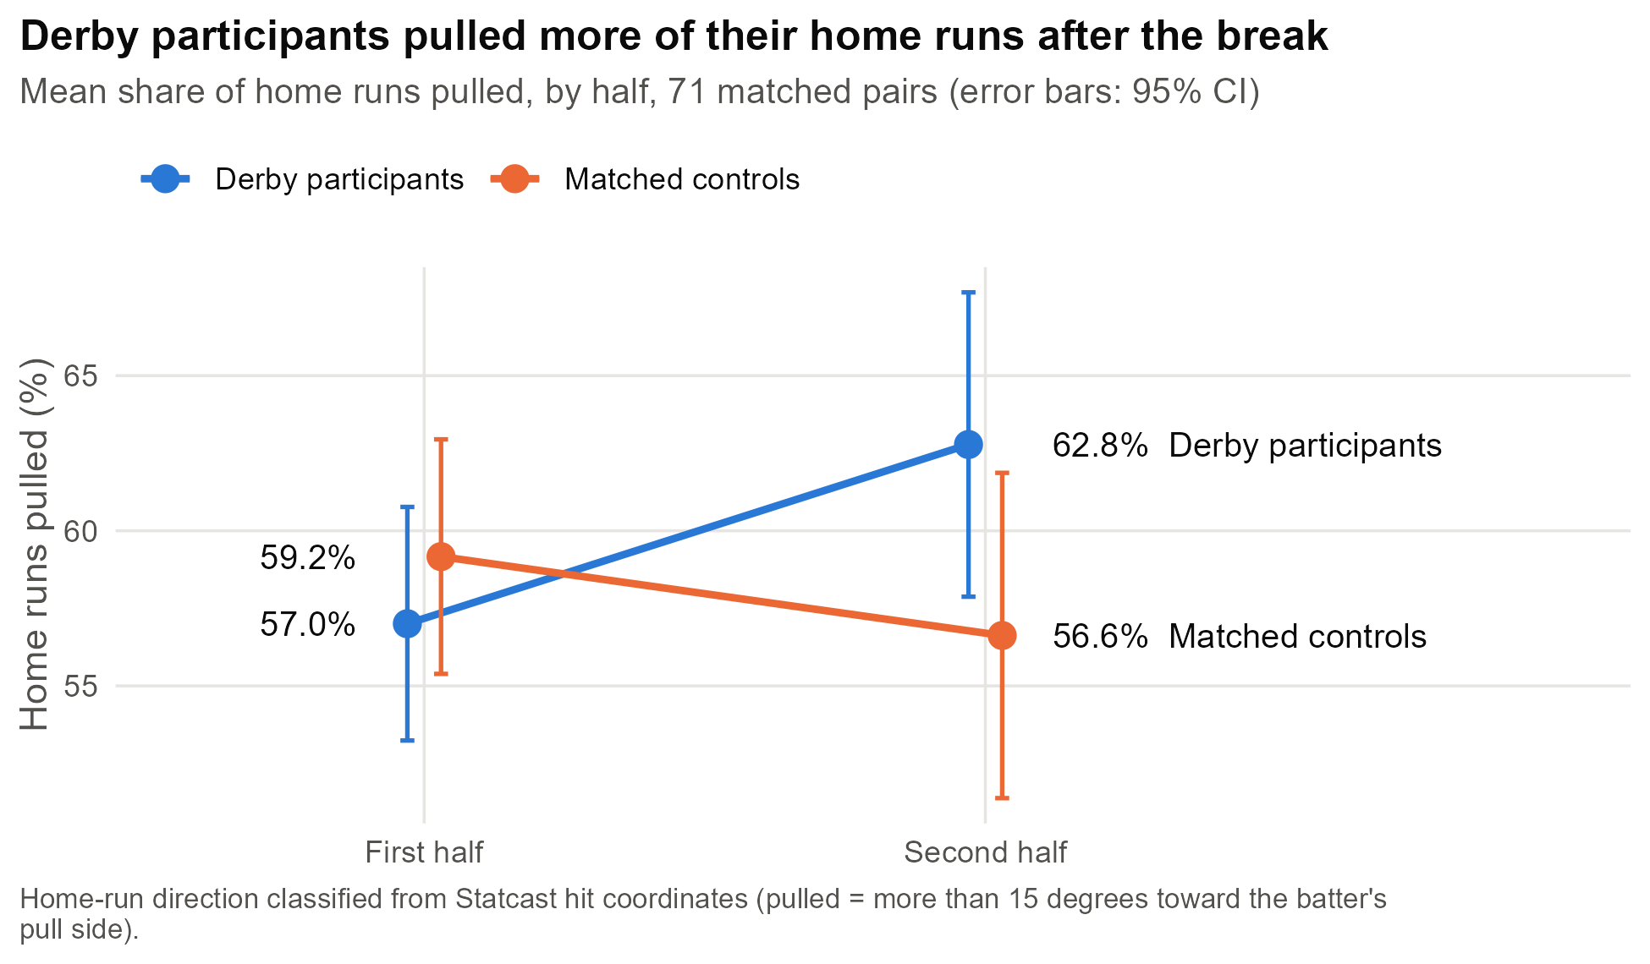
Derby participants pulled 57.0% of their home runs in the first half of the season and 62.8% after the break, while matched controls decreased from 59.2% to 56.6% (Figure 2). Compared with matched controls who had the same first-half HR Pull% and batted-ball profile, Derby participants' share of pulled home runs rose by an estimated 6.9 percentage points more after the break (97.5% CI [−0.3, 14.1], p = .031), narrowly missing the Bonferroni-corrected threshold of α = .025; this is suggestive rather than significant evidence. HR/FB declined in both groups after the break, but less among participants (adjusted difference 1.9 percentage points, 97.5% CI [−0.3, 4.0], p = .049), also not significant at α = .025.
Each estimate points toward Home Run Derby participation being associated with a more pull-oriented approach. However, no difference between participants and their matched controls is statistically significant. The results are therefore consistent with either no effect or a modest one, and the 95% confidence intervals argue against a large change in approach. Of the outcomes tested, home-run direction came closest to significance and is the most promising lead for continued research.
A challenge faced while generating these results was the toil of data collection and organization. FanGraphs blocks automated downloads, so its leaderboards were copied by hand for each season and half and checked against existing entries. The need to exclude 14 of the eligible participants is also a shortcoming, as this reduces the robustness of the dataset and limits confidence in potential influences. Next steps include a within-subject comparison for the 14 unmatched participants and a direct measure of pulled fly balls, which the Pull-Air Index approximates by averaging two separate rates.
References
Armstrong, R. A. (2014). When to use the Bonferroni correction. Ophthalmic and Physiological Optics, 34(5), 502-508.
Barnett, A. G., van der Pols, J. C., & Dobson, A. J. (2005). Regression to the mean: What it is and how to deal with it. International Journal of Epidemiology, 34(1), 215-220.
Baseball Savant. (n.d.). Statcast search [Data set]. MLB Advanced Media. https://baseballsavant.mlb.com
FanGraphs. (n.d.). Splits leaderboards [Data set]. https://www.fangraphs.com
Stuart, E. A. (2010). Matching methods for causal inference: A review and a look forward. Statistical Science, 25(1), 1-21.

